Giancarlo Barillas

HW 6

3/3/18

Prof Peisong Huang

**Code:**

**XML FILES:**

**Activity_main.xml:**

*<?***xml version="1.0" encoding="utf-8"***?>*<**RelativeLayout xmlns:android="http://schemas.android.com/apk/res/android"  
 xmlns:app="http://schemas.android.com/apk/res-auto"  
 xmlns:tools="http://schemas.android.com/tools"  
 android:layout_width="match_parent"  
 android:layout_height="match_parent"  
 tools:context="org.example.lab6.MainActivity"**>  
  
 <**TextView  
 android:id="@+id/textView"  
 android:layout_width="wrap_content"  
 android:layout_height="wrap_content"  
 android:layout_below="@+id/imageView"  
 android:layout_centerHorizontal="true"  
 android:text="Example of Services"  
 android:textSize="30sp"  
 app:layout_constraintBottom_toBottomOf="parent"  
 app:layout_constraintLeft_toLeftOf="parent"  
 app:layout_constraintRight_toRightOf="parent"  
 app:layout_constraintTop_toTopOf="parent"** />  
  
 <**ImageView  
 android:id="@+id/imageView"  
 android:layout_width="wrap_content"  
 android:layout_height="wrap_content"  
 android:layout_alignParentLeft="true"  
 android:layout_alignParentStart="true"  
 android:layout_alignParentTop="true"  
 app:srcCompat="@drawable/iit"** />  
  
 <**Button  
 android:id="@+id/startservicebutton"  
 android:layout_width="300dp"  
 android:layout_height="wrap_content"  
 android:layout_below="@+id/textView"  
 android:layout_centerHorizontal="true"  
 android:text="Start Services"** />  
  
 <**Button  
 android:id="@+id/startbutton"  
 android:layout_width="100dp"  
 android:layout_height="wrap_content"  
 android:layout_alignLeft="@+id/startservicebutton"  
 android:layout_alignStart="@+id/startservicebutton"  
 android:layout_below="@+id/startservicebutton"  
 android:onClick="onStartClick"  
 android:text="Start"** />  
  
 <**Button  
 android:id="@+id/stopbutton"  
 android:layout_width="100dp"  
 android:layout_height="wrap_content"  
 android:layout_below="@+id/startservicebutton"  
 android:layout_toEndOf="@+id/startbutton"  
 android:layout_toRightOf="@+id/startbutton"  
 android:onClick="onStopClick"  
 android:text="Stop"** />  
  
 <**Button  
 android:id="@+id/resetbutton"  
 android:layout_width="100dp"  
 android:layout_height="wrap_content"  
 android:layout_below="@+id/startservicebutton"  
 android:layout_toEndOf="@+id/stopbutton"  
 android:layout_toRightOf="@+id/stopbutton"  
 android:onClick="onResetClick"  
 android:text="Reset"** />  
  
 <**Button  
 android:id="@+id/stopservicebutton"  
 android:layout_width="300dp"  
 android:layout_height="wrap_content"  
 android:layout_alignLeft="@+id/startbutton"  
 android:layout_alignStart="@+id/startbutton"  
 android:layout_below="@+id/startbutton"  
 android:text="Stop Service"** />  
  
 <**TextView  
 android:id="@+id/displaytext"  
 android:layout_width="wrap_content"  
 android:layout_height="wrap_content"  
 android:layout_below="@+id/stopservicebutton"  
 android:layout_centerHorizontal="true"  
 android:layout_marginTop="11dp"  
 android:text="DISPLAY TIME"  
 android:textSize="30sp"** />  
  
</**RelativeLayout**>

**AndroidManifest.xml:**

*<?***xml version="1.0" encoding="utf-8"***?>*<**manifest xmlns:android="http://schemas.android.com/apk/res/android"  
 package="org.example.lab6"**>  
  
 <**application  
 android:allowBackup="true"  
 android:icon="@mipmap/ic_launcher"  
 android:label="@string/app_name"  
 android:roundIcon="@mipmap/ic_launcher_round"  
 android:supportsRtl="true"  
 android:theme="@style/AppTheme"**>  
 <**activity android:name=".MainActivity"**>  
 <**intent-filter**>  
 <**action android:name="android.intent.action.MAIN"** />  
  
 <**category android:name="android.intent.category.LAUNCHER"** />  
 </**intent-filter**>  
 </**activity**>  
  
 <**service  
 android:name=".MyService"**></**service**>  
 </**application**>  
  
</**manifest**>

**JAVA:**

**MainActivity.java**

**package** org.example.lab6;  
  
**import** android.content.ComponentName;  
**import** android.content.Intent;  
**import** android.content.ServiceConnection;  
**import** android.os.Handler;  
**import** android.os.IBinder;  
**import** android.support.v7.app.AppCompatActivity;  
**import** android.os.Bundle;  
**import** android.view.View;  
**import** android.widget.Button;  
**import** android.widget.TextView;  
  
**import** org.w3c.dom.Text;  
  
**public class** MainActivity **extends** AppCompatActivity {  
 **private** Button **buttonBind**;  
 **private** Button **buttonUnbind**;  
 **private** MyService **myService**;  
 **private boolean isBind**;  
 ServiceConnection **serviceConnection**=**new** ServiceConnection() {  
 @Override  
 **public void** onServiceConnected(ComponentName componentName, IBinder iBinder) {  
 MyService.DemoBinder demoBinder=(MyService.DemoBinder)iBinder;  
 **myService**=demoBinder.getServiceInstance();  
 **myService**.showMessage(**"Welcome to Bound Service"**);  
 **isBind**=**true**;  
 }  
  
 @Override  
 **public void** onServiceDisconnected(ComponentName componentName) {  
 **isBind**=**false**;  
 }  
 };  
  
 **private int millseconds**;  
 **private boolean running**;  
  
 @Override  
 **protected void** onCreate(Bundle savedInstanceState) {  
 **super**.onCreate(savedInstanceState);  
 setContentView(R.layout.***activity_main***);  
 **buttonBind**=(Button)findViewById(R.id.***startservicebutton***);  
 **buttonUnbind**=(Button)findViewById(R.id.***stopservicebutton***);  
 **buttonBind**.setOnClickListener(**new** View.OnClickListener() {  
 @Override  
 **public void** onClick(View view) {  
 Intent intent=**new** Intent(MainActivity.**this**,MyService.**class**);  
 bindService(intent,**serviceConnection**,***BIND_AUTO_CREATE***);  
 }  
 });  
 **buttonUnbind**.setOnClickListener(**new** View.OnClickListener() {  
 @Override  
 **public void** onClick(View view) {  
 **if**(**isBind**){  
 unbindService(**serviceConnection**);  
 **isBind**=**false**;  
 }  
 }  
 });  
 **if**(savedInstanceState!=**null**){  
 **running**=savedInstanceState.getBoolean(**"running"**);  
 **millseconds**=savedInstanceState.getInt(**"milliseconds"**);  
 }  
 runTimer();  
  
 }  
  
 **public void** onStartClick(View V){  
 **running**=**true**;  
 }  
 **public void** onResetClick(View V){  
 **running**=**false**;  
 **millseconds**=0;  
 }  
 **public void** onStopClick(View V){  
 **running**=**false**;  
 }  
  
 **public void** onSaveInstatnceState(Bundle savedInstanceState){  
 savedInstanceState.putBoolean(**"running"**,**running**);  
 savedInstanceState.putInt(**"milliseconds"**,**millseconds**);  
 }  
  
 **public void** runTimer(){  
 **final** TextView textView=(TextView)findViewById(R.id.***displaytext***);  
 **final** Handler handler=**new** Handler();  
 handler.post(**new** Runnable() {  
 @Override  
 **public void** run() {  
 **int** hours=(**millseconds**/(1000*60*60)%24);  
 **int** minutes=(**millseconds**/(1000*60)%60);  
 **int** seconds=(**millseconds**/(100)%60);  
 **int** milli=**millseconds**%100;  
 String time=String.*format*(**"%02d:%02d:%02d:%02d"**,hours,minutes,seconds,milli);  
 textView.setText(time);  
 **if**(**running**){  
 **millseconds**++;  
 }  
 handler.postDelayed(**this**,1);  
 }  
 });  
 }  
}

**MyService.java**

**package** org.example.lab6;  
  
**import** android.app.Service;  
**import** android.content.Intent;  
**import** android.os.Binder;  
**import** android.os.IBinder;  
**import** android.widget.Toast;  
  
**public class** MyService **extends** Service {  
 IBinder **iBinder**=**new** DemoBinder();  
 @Override  
 **public** IBinder onBind(Intent intent) {  
 Toast.*makeText*(MyService.**this**,**"Service Bind"**,Toast.***LENGTH_SHORT***).show();  
 **return iBinder**;  
 }  
  
 **class** DemoBinder **extends** Binder{  
 **public** MyService getServiceInstance(){  
 **return** MyService.**this**;  
 }  
 }  
 **public void** showMessage(String message){  
 Toast.*makeText*(MyService.**this**,**"Testing :"**,Toast.***LENGTH_SHORT***).show();  
 }  
  
 @Override  
 **public boolean** onUnbind(Intent intent) {  
 Toast.*makeText*(MyService.**this**,**"Service Unbind"**,Toast.***LENGTH_SHORT***).show();  
 **return super**.onUnbind(intent);  
 }  
}

**Images:**

**App main screen**

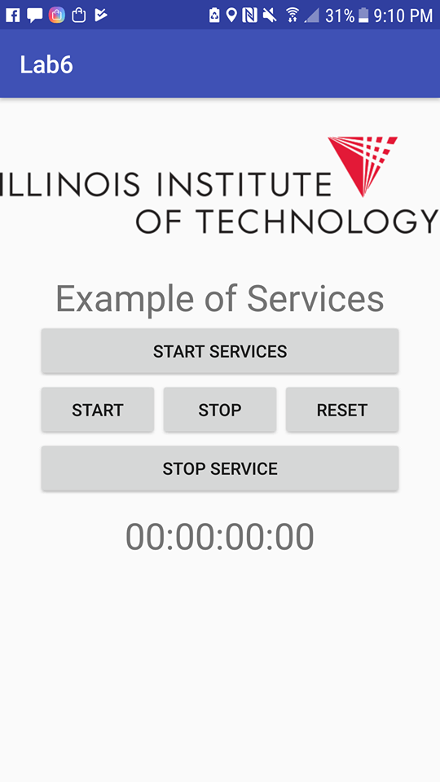

**App start Service button pressed**

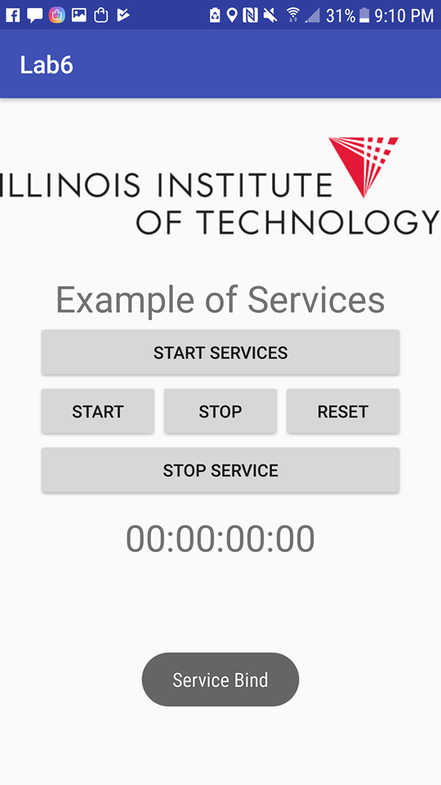

**App start Stopwatch button pressed**

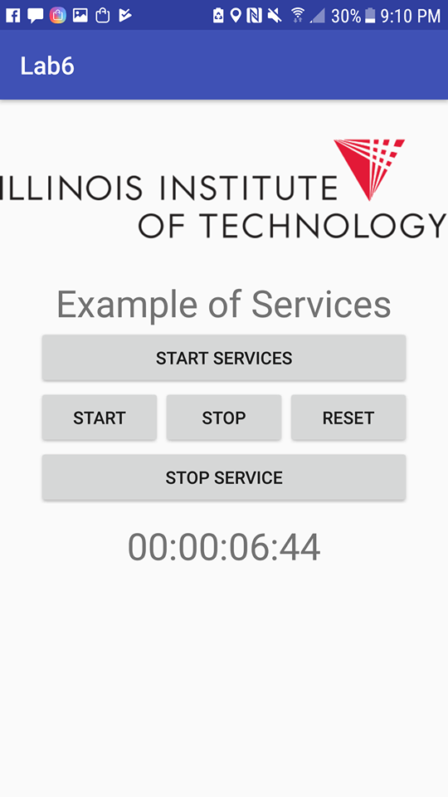

**App Stop Stopwatch button pressed**

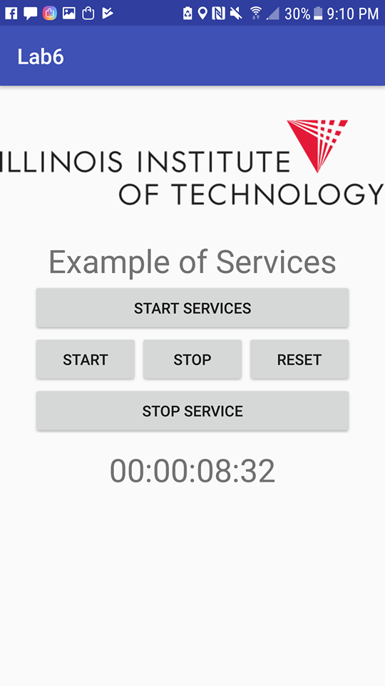

**App reset Stopwatch button pressed**

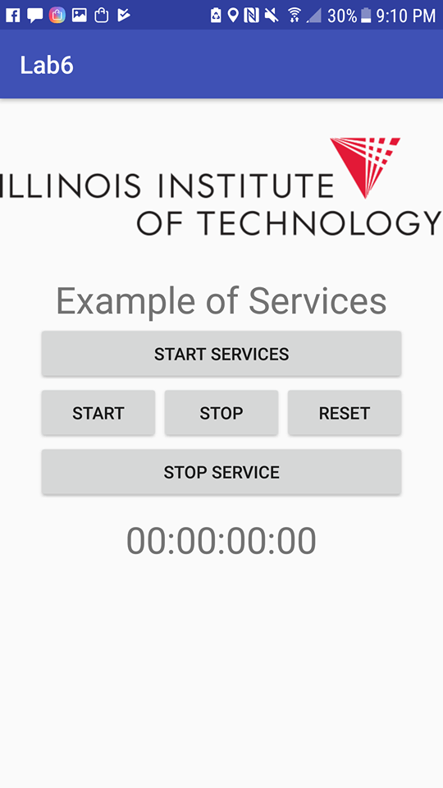

**App stop Service button pressed**

